lists to dictionaries

String and lists are subclass of sequence

Lists are dynamic, they grow and shrink as required

Sequence operations

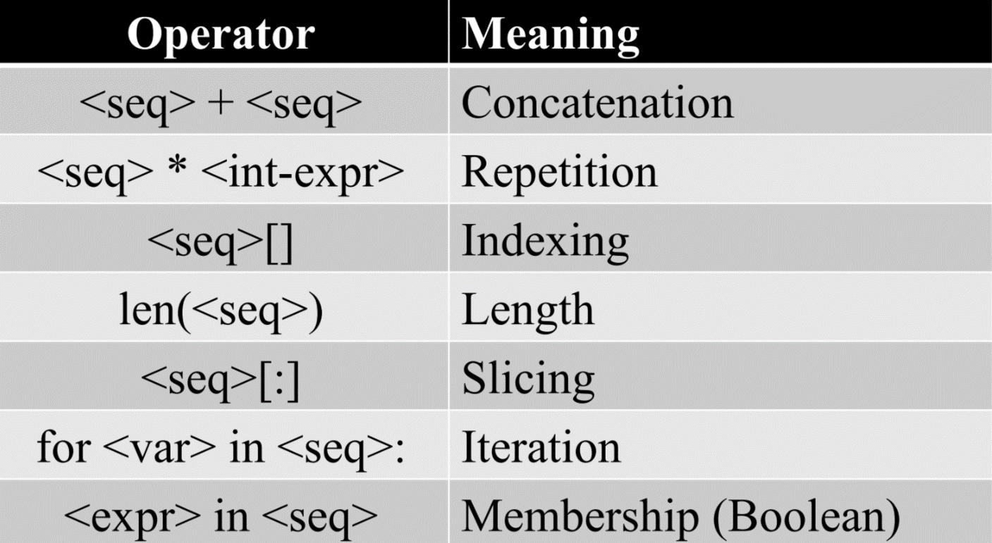

P: you can do them for the string, and you can do that in the string

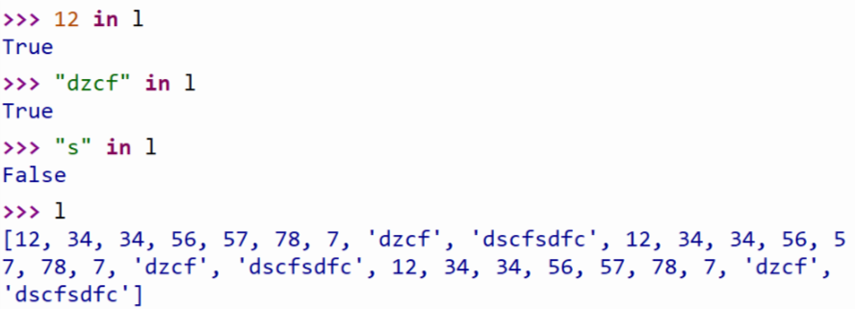

List operations

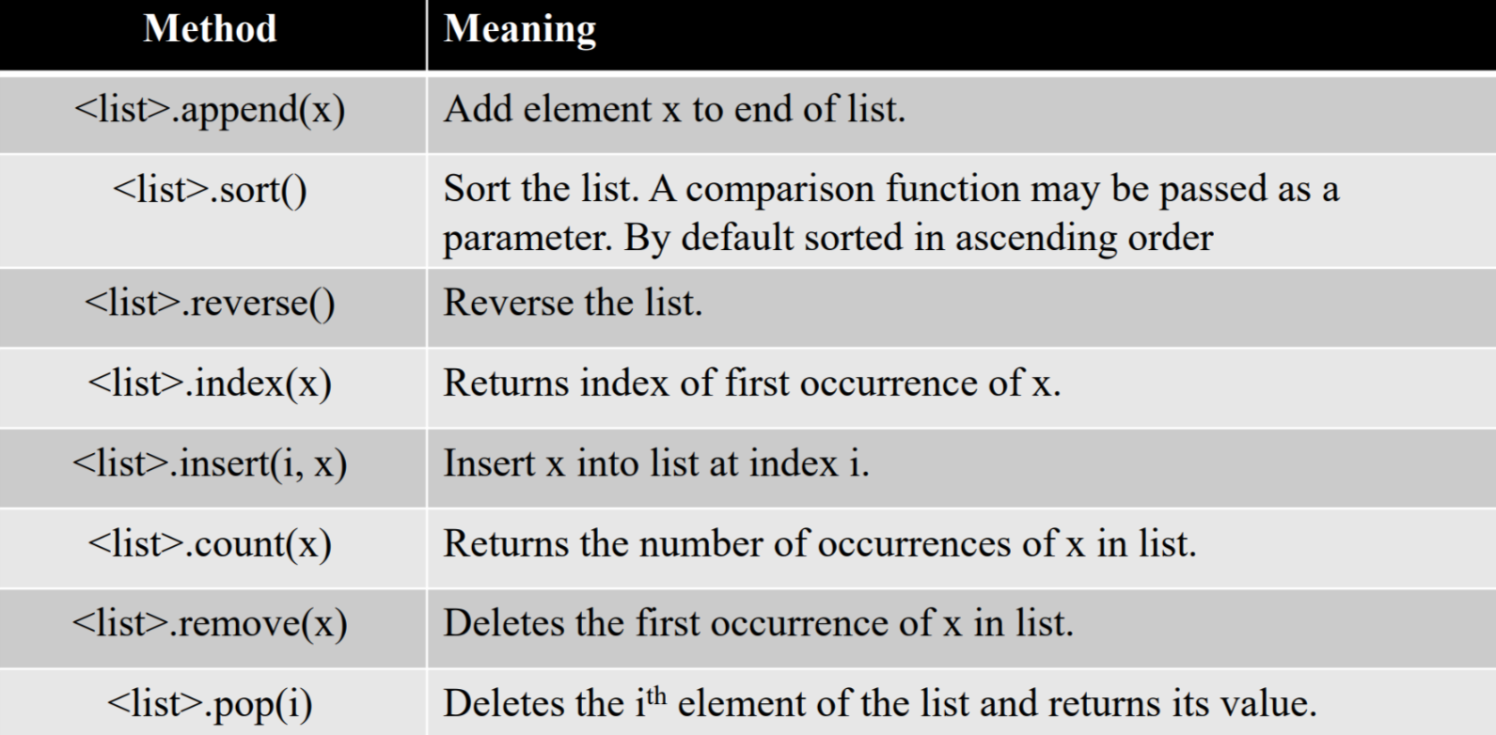

P:

1. most of the method don’t return the value, they change the contents of the list in some way. (They return None)
2. individual items or entire slices can be removed from a list using the del operator.

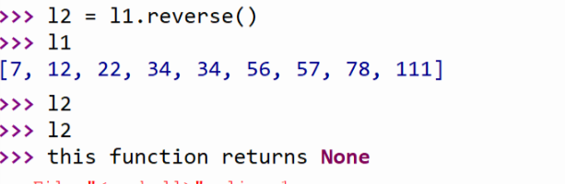

Index function

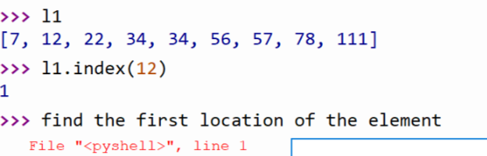

Count function: count how many values appear in the list

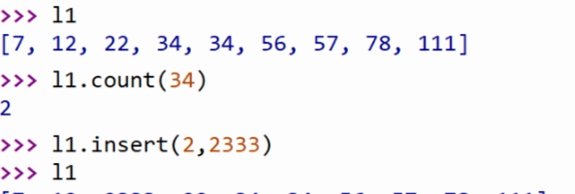

Insert function

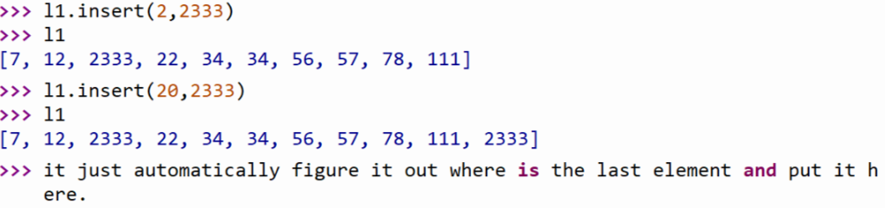

Remove function

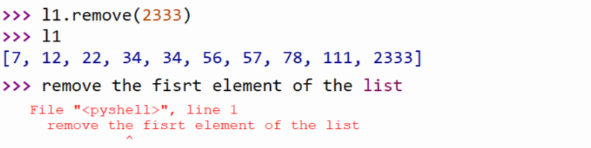

Pop (location): remove the element in that location and return the value

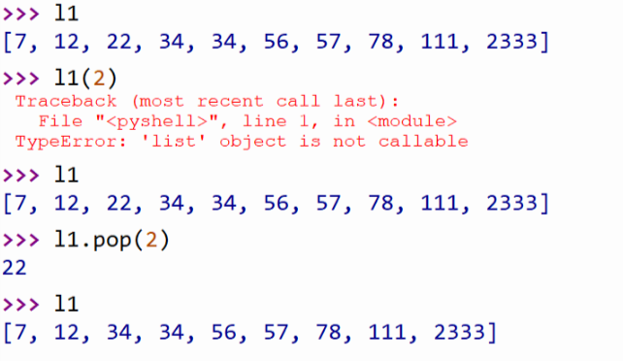

Sort (reverse = True) -> it equals to the sort + reverse

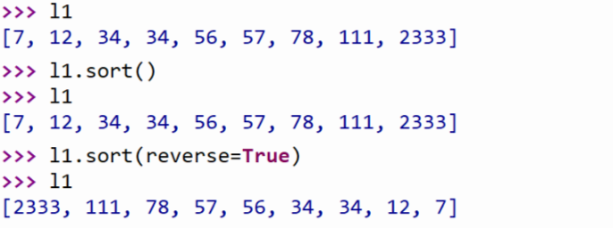

Del function: element or slice are all fine

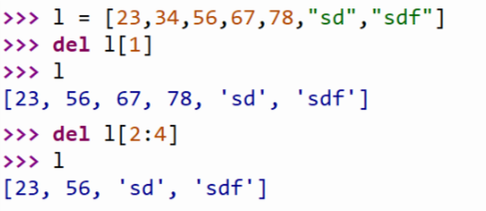

Tuple

The basic operation of the tuple is similar with the list

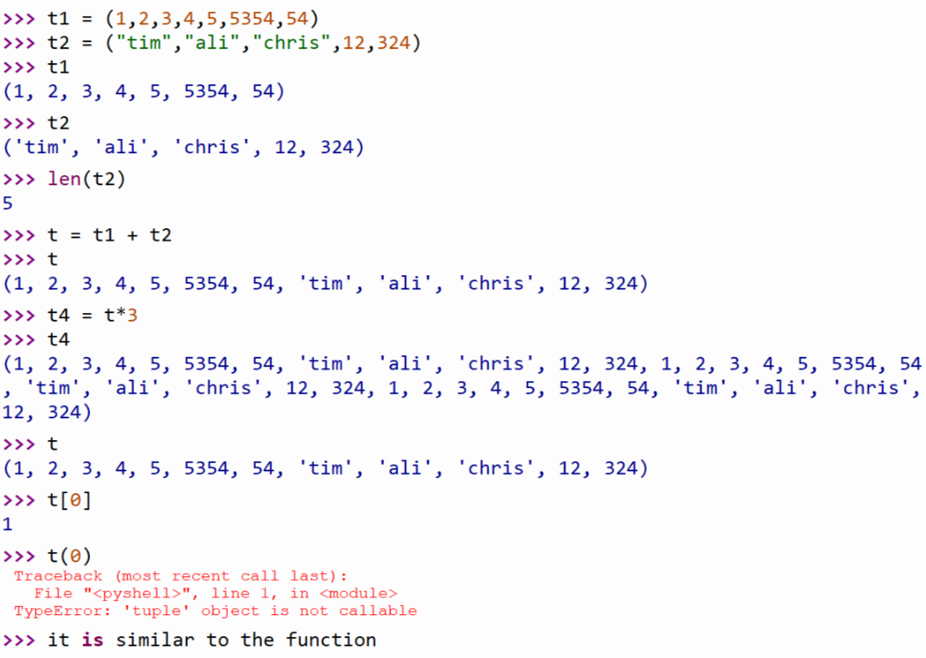

But tuple is immutable, you cannot change the element or append the elements or even delete the elements

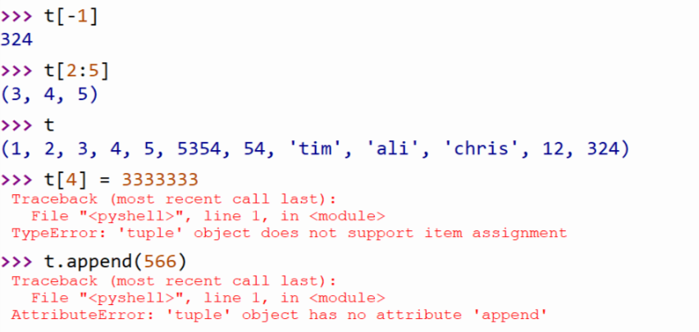

Tuple can be used in the name system, if you want to change the name, you need to change the whole name rather than the surname or the last name

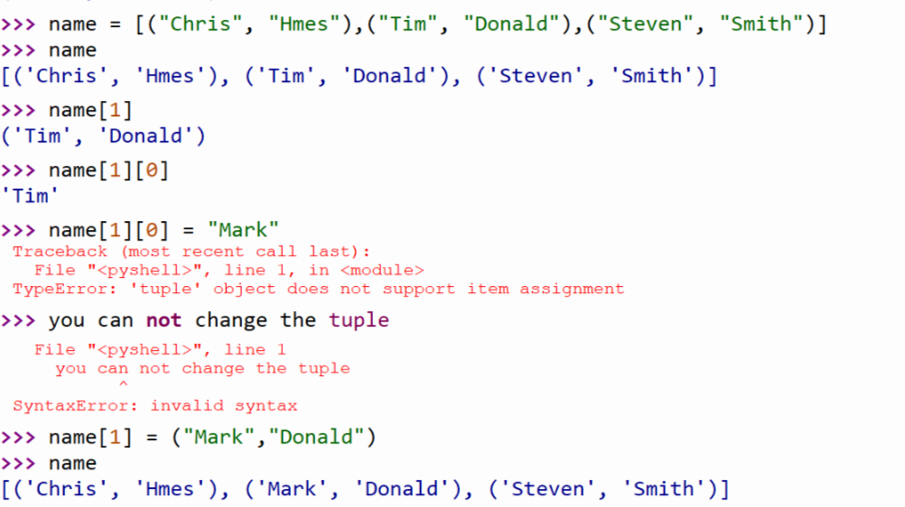

Tuple function: turn the sequence to the tuple

List function: turn the sequence to the list

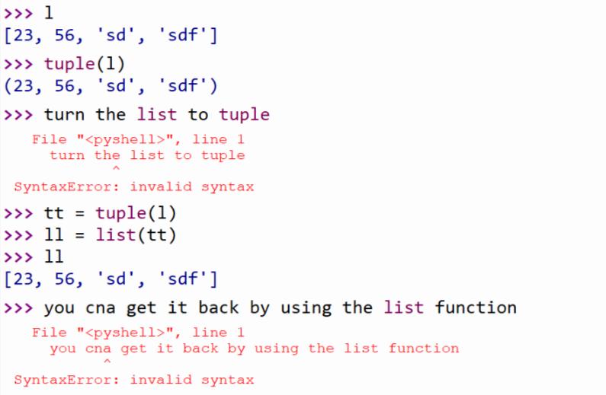

The relationship between the list and the tuple:

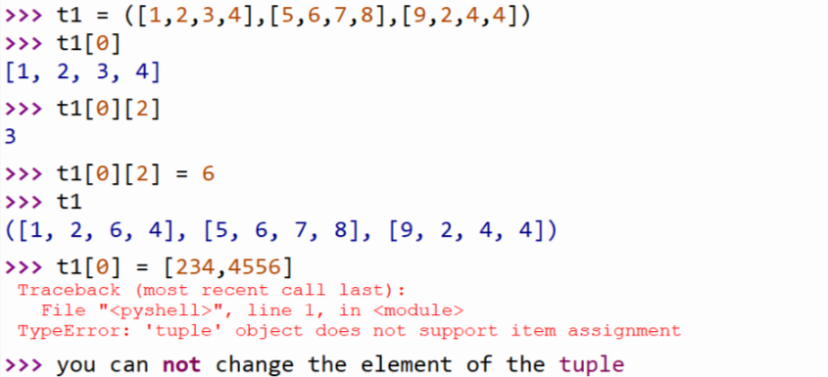

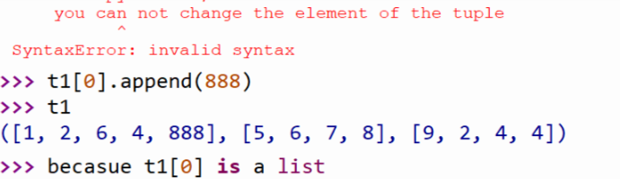

Dictionaries – it is about the storing technique

Compound: 混合物

Curly brace: 花括号

Catalogue: 目录

Dictionaries use key-value pairs

Like (names and the phone numbers, usernames and passwords, states and capitals)

Mapping: a collection that allow us to look up information associated with arbitrary keys

Python dictionaries are mappings. Other languages call them hashes or associative arrays

The order is fine because we do not know how it would store in the memory

Order doesn’t matter

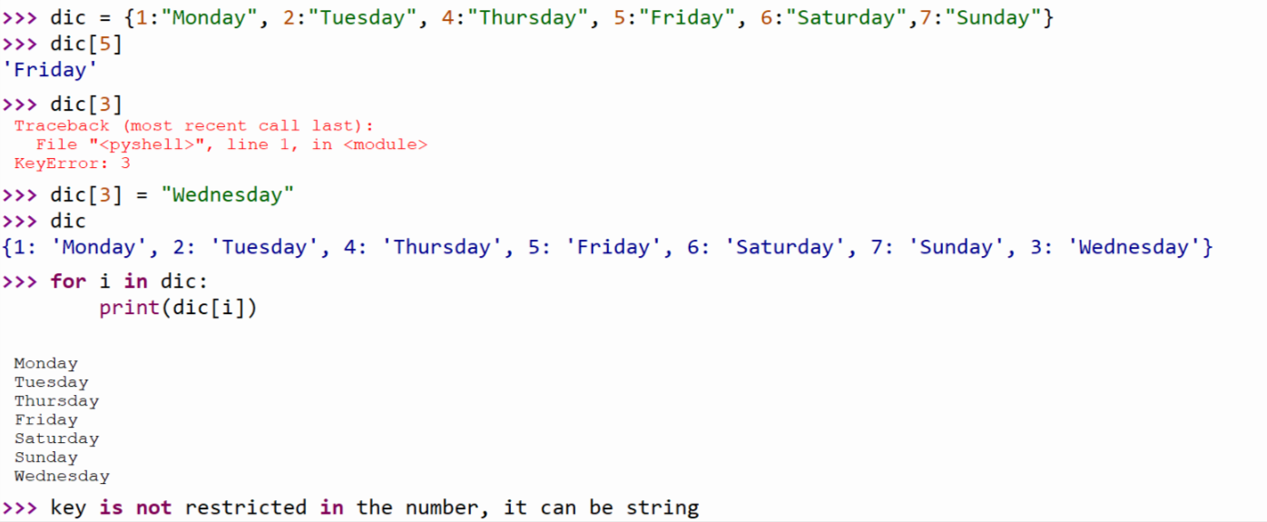

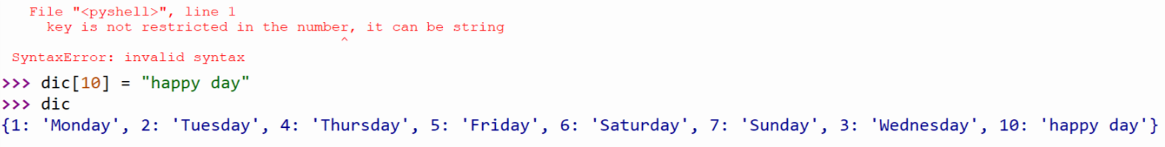

You are just finding the key and get the value

You can use an empty dictionary, and then add the key-value pairs / and then keep on populating with …